Packet Tracer – Skills Integration Challenge

1. Topology

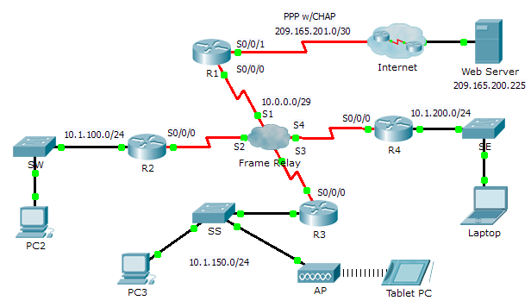

1. Addressing Table

|  |  |  |  |  |
| --- | --- | --- | --- | --- |
| Device | Interface | IPv4 Address | Subnet Mask | **Default Gateway** |
| R1 | S0/0/0 | 10.0.0.1 | 255.255.255.248 | N/A |
| S0/0/1 | 209.165.201.2 | 255.255.255.252 | N/A |
| R2 | G0/0 | 10.1.100.1 | 255.255.255.0 | N/A |
| S0/0/0 | 10.0.0.2 | 255.255.255.248 | N/A |
| R3 | G0/0 | 10.1.150.1 | 255.255.255.0 | N/A |
| S0/0/0 | 10.0.0.3 | 255.255.255.248 | N/A |
| R4 | G0/0 | 10.1.200.1 | 255.255.255.0 | N/A |
| S0/0/0 | 10.0.0.4 | 255.255.255.248 | N/A |
| Web | NIC | 209.165.200.226 | 255.255.255.252 | 209.165.200.225 |
| PC2 | NIC | 10.1.100.10 | 255.255.255.0 | 10.1.100.1 |
| PC3 | NIC | 10.1.150.10 | 255.255.255.0 | 10.1.150.1 |
| Tablet PC | NIC | 10.1.150.20 | 255.255.255.0 | 10.1.150.1 |
| Laptop | NIC | 10.1.200.10 | 255.255.255.0 | 10.1.200.1 |

1. DLCI Mappings

|  |  |  |  |  |
| --- | --- | --- | --- | --- |
| **From / To** | **R1** | **R2** | **R3** | **R4** |
| **R1** | - | 102 | 103 | 104 |
| **R2** | 201 | - | 203 | 204 |
| **R3** | 301 | 302 | - | 304 |
| **R4** | 401 | 402 | 403 | - |

1. Background

This activity allows you to practice a variety of skills, including configuring Frame Relay, PPP with CHAP, EIGRP, static, and default routing.

1. Requirements

R1

* Configure **R1** to use PPP with CHAP on the link to the Internet. **ISP** is the router hostname. The password for CHAP is **cisco**.
* Configure a default route to the Internet. Use the exit interface.
* Configure a static route to the LAN on **R4**. Use the next-hop IP address.
* Configure EIGRP.
  1. Use AS number 100.
  2. Advertise the entire 10.0.0.0/8 network and disable automatic summarization.
  3. Propagate the default route.
* Configure full mesh Frame Relay.
  1. Configure Frame Relay encapsulation.
  2. Configure a map to each of the other routers. The PVC to **R4** uses IETF encapsulation.
  3. The LMI type is ANSI.

R2 and R3

* Configure EIGRP.
  1. Use AS number 100.
  2. Advertise the entire 10.0.0.0/8 network and disable automatic summarization.
  3. Do not send EIGRP messages out the LAN interfaces.
* Configure full mesh Frame Relay.
  1. Configure Frame Relay encapsulation.
  2. Configure a map to each of the other routers. The PVC to **R4** uses IETF encapsulation.
  3. The LMI type is ANSI.

R4

* Configure static and default routing.
  1. Configure a static route for each of the LANs on **R2** and **R3**. Use the next-hop IP address.
  2. Configure a default route to R1. Use the next-hop IP address.
* Configure full mesh Frame Relay.
  1. Configure Frame Relay encapsulation using IETF.
  2. Configure a map to each of the other routers.
  3. The LMI type is ANSI.

Verify End-to-End Connectivity

* All end devices should now be able to ping each other and the **Web Server**.
* If not, click **Check Results** to see what configurations you may still be missing. Implement necessary fixes and retest for full end-to-end connectivity.